Contents

Company Philosophy & Objectives 2

Administrative 7

Filing Systems 7

Condo/Lender Questionnaire 7

Title Company Questionnaire 7

Travel & Expenses Forms 7

Work Orders 7

Incident Reports 8

Quarterly Safety Reports 8

Property Information Sheet 8

Service/Assistive Animal Accommodation Form 8

Calendars 9

Licensing & Documentation 9

Secretary of State (SOS) 9

Occupational License 10

Legal 10

Elevator 10

Tax Returns 10

Insurance Claims 10

Accounting 10

Budgets 10

Check Requests/Hot Potato 10

Property One Whitney Credit Card 11

Corporate Home Depot/Lowes Card 11

Invoices/Accounts Payable 11

Property One Invoice Approval Limits 11

Current Charges 11

Yardi 12

Resident Information 12

Monthly Homeowner Statements 13

Apartment Move Out Procedure 14

End of Month Budget Comparison 15

Contracts 15

Project Administration Fee 16

Monthly Management Report 16

After Hours Call Out Procedure 16

Staff: Emergency After Hours Call 17

Manager: Emergency After Hours Call 19

Aged Receivables/ Work Order Reports 20

Current Resident Aged Receivables 20

Past Resident Aged Receivables 20

Work Order Report 20

Collections 20

Miscellaneous 22

Bonus and Commissions Eligibility 22

Eligibility of Bonuses 22

Eligibility of Commissions 22

Slack Guidelines and Etiquette 23

Hurricane/Weather Systems 23

# Company Philosophy & Objectives

Property One, Inc., serves three major constituencies: (1) clients, (2) employees, and (3) communities. Long-range profit is our major responsibility so that we can continue to service our constituencies in the future.

The achievement of long-range profit is the result of the combined efforts of each individual in Property One working toward common objectives. These objectives should be realistic, should be clearly understood by everyone in the organization, and should reflect the organization’s basic character and personality. These objectives are summed up in our Company Motto:

**KEEP IT SIMPLE**

**MAKE A PROFIT**

**HAVE FUN**

If the organization is to fulfill its objectives, it should strive to meet certain other fundamental requirements.

FIRST, the **MOST** capable people available should be selected for each assignment in the organization.

SECOND, **ENTHUSIASTIC ATTITUDES** should exist at all levels. People in all positions should not only be enthusiastic themselves, they should be selected for their ability to engender enthusiasm among their associates.

THIRD, everyone should work in **UNISON** toward common objectives and avoid working at cross purposes if the ultimate in effectiveness and achievement is to be obtained.

It is the policy of Property One to have overall objectives which are clearly stated, and to give people the flexibility to work toward those goals in ways that are best for their own areas of responsibility.

Those services offered to our real estate and business clients are:

* Property and Asset Management
* Office, Retail and Industrial Leasing
* Tenant and Sales Representation
* Commercial Investment Brokerage
* Appraisals
* Consulting
* Land Sales
* Site Locating Service
* Related Accounting Services
* Maintenance Services
* Construction Management

**PROPERTY ONE’S STATEMENT OF PURPOSE**

The company shall be a highly profitable, skillful, respected, and recognized southeastern regional, commercial real estate management, leasing and brokerage firm headquartered in Metairie (New Orleans), Louisiana. The company will not own any properties; its income shall be derived wholly from property management, leasing, brokerage sales, and consulting fees.

The purpose of the Property Management and Leasing division shall be to provide to the ownerships of the properties managed, the highest possible return on their investments, considering both the goals of ownership and the economic lives of the properties.

New business will be derived from: (1) new third-party fee contracts for investor and institutionally owned accounts, (2) new fee business obtained through the brokerage of income properties to investor accounts, (3) developer accounts with subsequent lease-up marketing programs, and (4) expansion into other markets by opening new offices or by engaging in joint ventures.

The Brokerage division will perform leasing, sales, and acquisitions with an emphasis on exclusive tenant and sales representation contracts with sellers and buyers of properties. The primary focus will be to provide individually tailored services to each client with an emphasis on personal attention. New business will be derived from 1) personal and business contacts of the owners of Property One, Property One affiliates and the individual Brokers, 2) referrals from Property One management accounts, 3) direct advertising and signage, and 4) co-brokerage relations with other brokerage firms.

To supplement and support both Management and Brokerage Divisions, Property One will maintain an accounting department capable of providing all accounting services necessary for the proper operations of the firm and its clients using the most modern up-to-date equipment, resources and highly trained personnel.

To attain this mission, policies and procedures have been developed to serve as a guide to employees and associates in the performance of their assigned duties and to standardize (when possible) such duties, thereby creating a more effective and efficient program in all areas of operation.

From time to time, these policies and procedures will be revised. Such revisions will be forwarded to all holders of the manuals for inclusion in their personal copies.

**20 COMMANDMENTS OF BUILDING MANAGEMENT**

In the conduct of everyday management activities there is a need for self-discipline in our relationship with tenants and prospective tenants. Learn and practice the 20 Commandments of Building Management until it becomes a habit. To do so will help insure your success as a professional.

1. GREET THE TENANT PROMPTLY – Even one minute is a long time when you are waiting.
2. SMILE – A smile is the trademark of a friendly person. We all like to deal with pleasant people.
3. CALL TENANTS BY NAME – The most important name in the world to a tenant is his own name.
4. DON’T ARGUE – Only fools have arguments, and if you win, you lose.
5. SELL YOUR BUILDING – When you talk well of your building, you also talk well of yourself.
6. SHOW YOUR APPRECIATION – A tenant does not like to feel that you are doing him a favor by serving him.
7. SHOW ENTHUSIASM – It’s contagious. If you are enthusiastic about your service and space, your tenant will be too.
8. BE A GOOD LISTENER – Most people would rather talk than listen.
9. SAY “THANK YOU” – Make its use a habit. It never gets old.
10. DON’T BE A “STUFFED SHIRT” – You can’t build a false front that tenants can’t see through. Just be friendly.
11. PUT YOURSELF IN THE TENANT’S SHOES – When unusual requests are made, place yourself in the tenant’s position. Now do you understand his point?
12. DO SMALL FAVORS – Big favors take time and are not expected.
13. KEEP COOL – Lost tempers lose tenants.
14. DON’T OVERDO IT – There is a vast difference between sincere appreciation and gushing flattery.
15. KNOW WHAT YOU ARE TALKING ABOUT – Tenants depend on you for advice. If you guess, you may guess wrong.
16. KEEP PROMISES – Confidence is the foundation on which business and friendship are built.
17. LOOK THE PART – People judge other people by their appearance.
18. BE TACTFUL – Simply stated, tact is consideration for the feelings of others.
19. DON’T OVERSELL – Good Salesmanship is not high pressure selling or overselling.
20. BE PROMPT – Take care of complaints immediately. When you say you will accomplish something by a given date, have it done on that date.

**THINGS A MANAGER SHOULD KNOW IF ASKED**

* What are your **top 5 goals** and objectives for each of your properties for this year?
* Do you have an operations/**property information manual** for each of your properties?
* What was your total CAM or Operating Expense cost per sq. ft. last year on each of your properties? How much per sq. ft. is projected for the current year?
* Do you know all of your tenants (i.e., primary contacts and principles) **by name**?
* Can you quote each of your tenants sq. ft. leased; lease expiration date; tenant sales volume/retail and how their sales compare to local, regional and national averages?
* Are you talking with each of your owners at least every two (2) weeks? Are you verifying that our performance is on track?
* Are you holding **weekly staff meetings** with the members of your team?
* Are your property files in order?
  + Tenant insurance certificates up-to-date?
  + Vendor insurance certificates up-to-date?
  + Copies of each vendor service contract on file?
  + Copy of management agreement on file?
* Can you quote your buildings’ current percentage of occupancy and asking rate for available space?
* Can you name your buildings’ **three (3) primary competitors**, their current occupancies and asking rental rates?
* Do you have a **specific plan** to increase your percentage of response and overall level of satisfaction on your next tenant and client satisfaction surveys?
* Are you collecting and/or have you requested that your happy tenants and clients send you **a letter of testimony**?
* Are you inspecting each of your properties on a **weekly basis**? Also, are you performing a minimum of at least **one (1) night inspection per month**?
* Are you reviewing your preventive maintenance files on a monthly basis to ensure that your engineers are taking care of the equipment and keeping the records current?
* Are you monitoring your tenant complaints on your tenant work order system?
* Are you involved in IREM, BOMA or ICSC?
* What are your goals for **continuing your education** and/or obtaining a professional designation?
* Do you read the business section of the paper on a daily basis? Do you read the weekly Business Journal? Do you regularly read industry related publications such as National Real Estate Investor, Commercial Property News, Buildings, Shopping Center World, etc.?
* What is happening in the immediate area of your property from a real estate standpoint?
* What could be done to make your property look better?
* What needs painting?
* What condition are your roofs in? Parking lot? Landscaping?
* Are your vacant suites, mechanical rooms, janitorial closets, tool rooms neat and clean?
* Are you having **monthly inspections** with your cleaning, landscaping or other contract services?
* Has your property assistant seen all of the properties managed out of your office?
* Do you have a **tenant handbook** for each of your properties?
* Have you established **emergency procedures** to deal with fire, flood, medical emergency, bomb threat, earthquake? (Including an evacuation plan?)
* Have you defined your professional and personal goals for the next year? Three years? Five years? If so, do you review your goals monthly? Weekly? Daily?
* Are you assisting your staff in the advancement of their careers, goals, training, etc.?
* Are you managing your time efficiently**? Do you have a daily, weekly, and monthly plan?**
* What is the title of the last book you read?
* How is your health? When was the last time you had your cholesterol, blood pressure, etc., tested?
* When was the last time you made a mistake? (Note: If you can’t remember, maybe you’re not taking enough risks or trying new or innovative ways of improving and performing your job.)

# Administrative

## Filing Systems

Each Property manager will maintain an organized filing system. All residents should have an individual file keep on site under lock and key. Files should contain any violations, TRID (HUD-1 Statements), leases and application information, email correspondences of importance, etc.

* Make sure that your onsite computers and servers are regularly backed up. CNC can provide this service for a monthly cost.

Condo/Lender Questionnaire

If the Board has approved to charge a fee, collect the fee upfront and the questionnaire should be completed within 72 hours.

Title Company Questionnaire

This should note any outstanding balances, capital reserve contributions and/or special assessments. This form should be completed as soon as possible or by the end of the business day.

Travel & Expenses Forms These should be used for travel and expense reimbursement and proper backup provided. All Property Manager will be approved by the Director of Operations once uploaded as a payable through Payscan. All travel and expenses forms turned in by staff of a Property Manager will be approved by the Property Manager. Under no circumstances should a T&E be reimbursed for expenses over 30 days old. Form can be found on the Intranet.

## Work Orders

Upon receiving a service call, the call work order is to be entered in Yardi maintenance and the maintenance engineer needs to be called to attend to the work order. Maintenance personnel are not allowed in units for maintenance request if there is a minor in the unit alone. Only exception would be an emergency situation. All work orders should be closed within 48 hours of receiving (some exceptions apply). A monthly work order report should be sent to the Director of Operations on the 15th of every month.

## Incident Reports

It is vitally important that the Property Manager is informed and aware immediately in the event of any unusual occurrence, activity or emergency and that such information is reported accurately and completely. All incidents are to be followed up with an incident report (see Sample A), which will list in detail all pertinent times, facts, people (names), areas involved, who responded, and how and what actions were taken. A copy of this report is to be prepared by the Property Manager immediately and forwarded to the Director of Operations and the Management Division Coordinator. In the event of an injury, the report should be forwarded to the CFO and Director of Operations. For injury to a Property One Employee please refer to Workers Comp Policy and Procedures.

## Quarterly Safety Reports

These are to be completed by the Property Manager and Maintenance Personnel. A full walkthrough of the building/property should be performed and look for any potential hazards or damaged equipment. Take not of all your life safety systems and when they are due for inspection. These reports should be sent to Management Division Coordinator after completion.

## Property Information Sheet

Each property should have a completed profile filled out and updated accordingly as things change. Once completed or if changes are made, please send to the Management Division Coordinator. This form can be found on the Intranet.

## Service/Assistive Animal Accommodation Form

When a request for a reasonable accommodation for a service or assistive animal is made by a resident it is imperative that you remember the following script to ensure we are consistent with our messaging: **“I will be happy to assist you with your request. In order to comply with fair housing laws, we need you to fill out some paperwork. Please give me your name and contact information and I will send over the forms.”** The forms can be found on the Intranet. As a precaution, whenever a request is made, please contact your Director of Operations to discuss the situation before moving forward with presenting any forms.

*A few things to remember:*

* + You **MAY NEVER ASK** what kind of disability a person has**.**
  + If the disability or disability-related need is readily apparent or already known to you, **only the Animal Identification Form (3rd page) is needed** and you cannot request the Reasonable Accommodations Verification form.
  + The 1st page of the packet is to be sent ***BY YOU*** to the medical provider ***AFTER*** the resident making the request fills out the 2nd and 3rd page. (The resident is not to take the 1st page and have it filled out on their own).

We do not have to accept online certification and if one is presented to you, please accept it and let the resident know we will evaluate his submission and get back with them shortly. This topic is evolving in our industry and we must follow Fair Housing guidelines to ensure we are not violating any rights of our residents.

# Calendars

* Every Monday morning, the Management Division Coordinator sends out the office and condo calendar for the next 2 weeks. Please check this calendar and alert with any changes immediately.
* Emergency Information Update- Reminders should be set on your calendar for every January 1st and July 1st (phone list, security codes, fire panel, security vendors, etc.)
* Send resident contact info to the Management Division Coordinator at the beginning of each month.
* Set reminders for important dates such as annual inspections for fire pumps, panels, generators, etc. Include other important dates such as Secretary of State renewal, monthly or quarterly pest control services, termite inspections and air filter change replacements to name a few.
* Check condo documents for when annual statement must be sent to each owner, normally within 120 days of end of year.

# Licensing & Documentation

## Secretary of State (SOS)

Pay annual renewal fee ($15) and update officers (BOD) and agent listed. Paul Dastugue must be listed as the agent or association’s attorney. Place a reminder of expiration on your calendar and on the office calendar.

## Occupational License

All apartments and commercial buildings must have an active license and are filed each year. Place a reminder of expiration on your calendar and on the office calendar.

## Legal

Any legal documents must come directly to Paul Dastugue. Do not accept or sign anything unless you, personally, are being sued.

## Elevator

All buildings with an elevator must have an active Certificate of Operation or permit. These typically are good for two years. Place a reminder of expiration on your calendar.

## Tax Returns

All prior year tax returns must be turned in by February to tax agent/owner/board. Tax returns are not to be signed by anyone other than the owner/board. Managers are not to sign tax returns. A copy of the completed and signed tax returns should be sent to accounting every year.

## Insurance Claims

Any incident (slip and fall, damage to the building or other person’s property) should be immediately reported to DOM and Boards/Owner and an incident report completed. If agreeable to the Board/Owner, your insurance agent should be contacted and put on notice. Documentation is key; pictures and statements are vital in these types of situations.

# Accounting

## Budgets

Every year the process for budgets is sent out along with a timeline of specific deadlines. Please reference notifications for specifics.

## Check Requests/Hot Potato

A check request must be submitted when an invoice is not available, (i.e. order number, confirmation page). A hot potato (HP) is used when payment/reimbursement is needed quickly. A HP must be turned into [accountspayble@propertyone.com](mailto:accountspayble@propertyone.com) by 10a in order to receive the check payment by 2p the same day.

## Property One Whitney Credit Card

We would like to limit the usage on this card and encourage each of you to consider other payment options if and when available. The card is not intended to be an ongoing line of credit and should also not be used to pay utility bills. If your property has cash flow issues, please verify that you have the funds to pay the following week.

If you have a need to use the credit card, please send an email to the Director of Operations - Multifamily first with the purpose of the use, name of the merchant and the total amount. Once approved, your email will be forward to John Silvey and he will issue you a PO# to use and provide the card details for you to make the purchase.  ***No purchases may be charged to the card without first obtaining approval from Director of Operations AND a PO#.*** Once you make the purchase and have received the receipt, attach it to a coded check request (see Intranet for Check Request from) with the PO# included. You will turn it in with your ***very next batch of invoices*** to ensure the charge gets paid off as quickly as possible to avoid interest/finance charges. **Please do not attach the credit card info sent to you by John with your back up.**

## Corporate Home Depot/Lowes Card

If your property is listed as an authorized user for the corporate accounts, it is imperative that receipts are turned in within 15 days and processed for payment. It is up to you to obtain the receipts from your staff and process in a timely manner to avoid late fees or discontinued use of the card.

## Invoices/Accounts Payable

* These should be turned in no later than 12p (noon) every Tuesday of the week. Invoices are to be emailed to [accountspayable@propertyone.com](mailto:accountspayable@propertyone.com)
* If an invoice is over your $1000 limit, the best practice it to have the Board President or Owner sign off on the invoice before submitting to accounts payable.

## Property One Invoice Approval Limits

* Admin. < $250
* Manager < $1,000
* Director of Operations < $2,500
* Paul Dastugue > $2,500

## Current Charges

You can only pay the ‘Current Charges’ shown on the bill. If the bill shows a prior balance, you should research the balance in Yardi to see if it has already been paid. If so, write your findings in the “nice notes’ section of Payscan, such as ‘paid 6/23 ck# 1234’ to affirm that you have seen the prior balance and done the research. Making sure the ck# has been Reconciled, of course, could be key in making sure the prior balance has been satisfied with the Vendor. If the prior balance has NOT been paid, request a copy of the prior detail from the Vendor and pay from that invoice, not the invoice showing a forwarding balance.

## Yardi

### Resident Information

All residents including owner tenants should be documented in Yardi. Each owner is to be labeled as one of the following: OWNER OCCUPANT, OWNER ABSENTEE, OWNER RENTED. If an owner rents his unit, the renter should be labeled as TENANT and their contact info should be placed in with the owner. Contact info for all residents should include, address, email and phone number. Below is a property summary dashboard which shows the resident makeup. This info can be helpful when filling out lender questionnaires and knowing which units are rented and owner occupied.

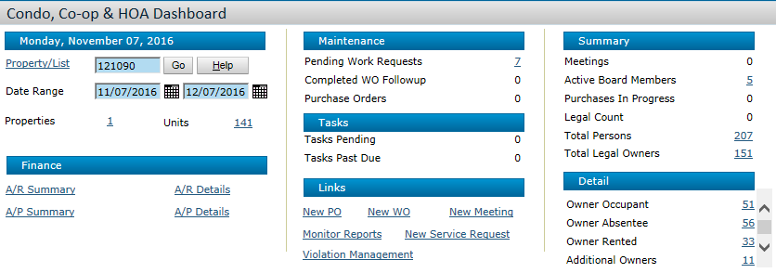

The below is a specific owner in Yardi and shows the resident’s contact info and occupants labeled correctly. Apartments should have the leaseholders listed first and any and all occupants listed as others/occupants.

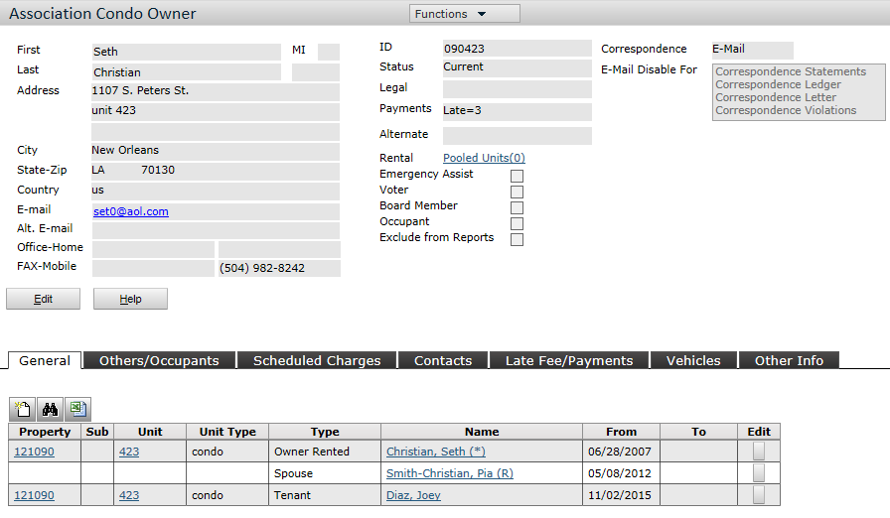

* TRID - (TILA / RESPA Integrated Disclosure) now replaces the HUD-1 Statements

The statements should be sent to your accountant in order to change ownership in Yardi. The TRID should also be uploaded to the resident’s profile under the attachment section and a hard copy placed in the owner file.

* Violations and other pertinent info should also be uploaded to the resident’s file in the Attachments sections.
* Billbacks are the responsibility of the manger and can be manually added in Yardi under Charges> Create Detail Batch or sent in on the Billback spreadsheet and forwarded to accounting for approval.

### Monthly Homeowner Statements

On or before the 28th of each month and only after the condo dues and charges have been posted by accounting, owner statements should be sent via email through Yardi or mailed (if requested by the owner). To send through Yardi:

**PM Condo > Correspondence > Invoice**

### Apartment Move Out Procedure

**This process MUST be done within 30 days of the expiration of the lease OR once the resident hands over possession.** Once the resident has given you notice to vacate, the first step is to put them on notice in Yardi under the Resident Screen.

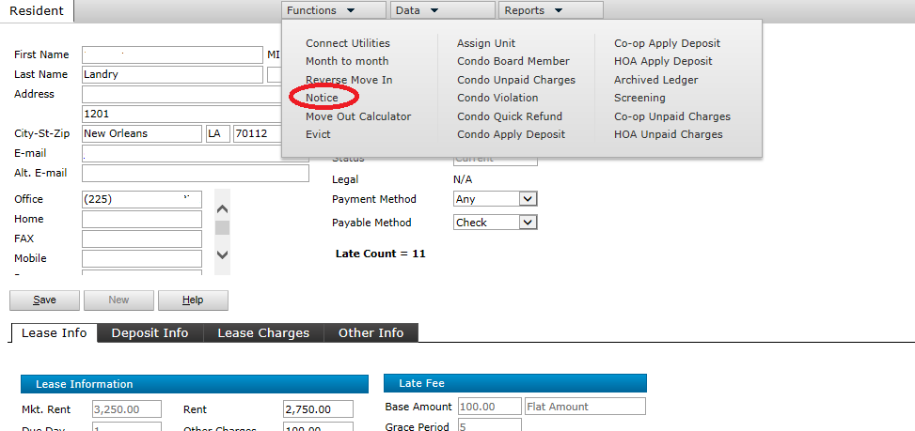

After a Resident moves out, the Property Manager must walk the unit within 24-hours to assess for damages. ***Within 5 days*** of the Resident Moving Out, please complete the **MOVE OUT CHARGE FORM** (see Intranet for Move Out Form). This form will be a summary of the move out detailing all charges that should be assessed i.e. damages, carpet replacement, missing keys or remotes, unpaid rent, broken items, missing appliances, eviction filing fees, legal fees, etc.

To process a MOVE OUT, you will need to create a **MOVE OUT PACKET** and forward to the Accounting Assistant in order to complete the Move Out Statement (**MOS**). In addition to the packet, you must change the status of the resident in Yardi and select the **MOVE OUT** function under the Resident’s Screen.

The Move out Packet must include the following:

* Completed Move Out Charge Form, including the Resident’s forwarding address
* The Resident Ledger
* The first page of the lease
* Lease Cancellation Addendum (if applicable)

The Resident File should contain:

* Move In/Move Out Checklist signed by Resident and Property Manager
* Copy of the Resident’s 60-day or 30-day written notice of intent to vacate
* Confirmation of utility transfer back to property or new tenant

If there are damages the following is to be uploaded as Attachments in Yardi to the Resident Screen:

* Copies of all invoices, bids, etc. for damages that we are billing to the Resident
* Pictures of damages

Once the MOS is complete and returned from accounting, *and if no balance is due*, the Property Manager is to review for accuracy, sign and date the MOS and return to the Accounting Assistant. They will then send the security refund check and the MOS to the resident’s forwarding address on file.

*If there is a balance due* to the property, the Manager is responsible for sending a letter and the residents including the MOS via certified mail.

## End of Month Budget Comparison

At the end of each month around the 25th, place a reminder on your calendar to review the current month’s **BUDGET COMPARISON** for your property(s).  You are looking for any missing bills in that month and any expenses that need to be re-classed. You should send your accountant any changes before the month ends.

* + To find the Budget Comparison report in Yardi:

**P1 Condo PM OR PM Residential PM >Analytics >Financial Analytics**

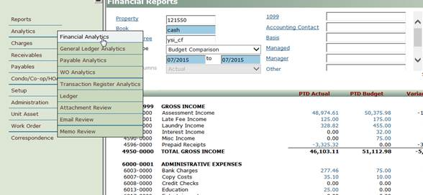

# Contracts

* Every vendor/contractor should have the proper licensing to do the scope of the work.
* Insurance certificates should be presented with any bid or quote before proceeding to the next step. The following are our requirements:
  + Workers Compensation and Employers’ Liability Insurance with limits of liability of not less than $500,000 covering all of Contractor’s employees. Policy will contain a Waiver of Subrogation endorsement in favor of Owner and Agent and should name both the Building and Property One as additional Insurers.
  + Comprehensive General Liability including Contractual Liability Products – Completed Operations Liability, Personal Injury and Advertising Injury with limits of liability of not less than $1,000,000 Combined Single Limit each occurrence $2,000,000 aggregate.
* Recurring Service Vendors (landscaping/cleaning service/trash disposal) should use the Vendor Service Contract
* Major Construction jobs should use the Contractors Work Agreement
* Both of these contracts can be found on the intranet. You must complete the proper contract, attached the bid/proposal/quote as one of the exhibits and have the vendor or contractor sign first. Once signed by the vendor/contractor, send to either Director of Operations - Multifamily/Director of Maintenance/Paul Dastugue along with any licensing and insurance certificates. They will sign off and approve and return.

## Project Administration Fee

Major projects that are not considered part of regular property maintenance and may require a third-party contractor will be eligible for a Project Administration Fee (“PAF”). The PAF is typically an additional 5% of the total contracted agreement unless a different amount is agreed upon between Property One and Ownership (Check property management agreement). Please check the Intranet for more info.

# Monthly Management Report

* Managers have 2 business days to send management reports to their BOD/Owner after receiving the financial report from your accountant. The forms to use unless otherwise specified by your BOD/Owner are attached. (See Management Report on the **Intranet**)
* Know your numbers and why there are variances.
* Spell Check- All correspondence including letters, emails, texts, etc. should be double checked for accuracy.

# After Hours Call Out Procedure

Each property manager is responsible for insuring calls are answered immediately or returned promptly if missed. The first contact on the call list will be the Property Manager and then the maintenance personnel. It is important for the property manager to determine the severity of the call and either dispatch maintenance or determine if the manager’s presence is also needed on site.

When a call is received, the property manager will decide on the next course of action. Generally speaking, fire, flood or blood are all triggers for “all hands on deck.” In any of these instances, the manager should head to the property and alert maintenance and upper management. Don’t forget to implement the Afterhours Procedure through Netchex to document and ensure all staff are paid accordingly. In addition, an incident report should be completed after the property is secure and before you leave the site. All incident reports should be sent to the Director of Operations.

If a call is received, the property manager will determine if it’s an emergency or a non-emergency and could be handled the following business day. Always ask the dispatcher to patch you through to the caller so that you can speak with the resident one on one. This allows you to communicate to the resident on a more personal level so they do not feel their call is unimportant. Once you have spoken to the resident, please call the answering service back and let them know you have handled the call and give a brief recap of the conversation. This allows upper management to see that the call was handled appropriately.

Again, please keep in mind our residents and clients depend on us to assist in resolving whatever issues they may be experiencing as quickly as possible. Don’t hesitate to call the police or fire department if you arrive on site and determine further action is required to ensure the safety of our residents.

## Staff: Emergency After Hours Call

If your maintenance employee is called out after hours (would not apply if employee is already onsite from normal business hours including staying late), a flat fee of $50 will be paid to the employee in addition to time and half for any hours worked onsite. This time should be documented by using the punch in/punch out method through the Netchex system.

There are two steps to this procedure and these should be followed exactly.

1. When the employee arrives and leaves the site, they must punch in/punch out through Netchex. Please note the **Div/Bu/Dept** code should have the words **(CALL OUT)** as the prefix to the building location. See example below:

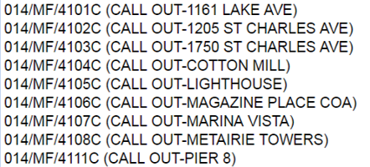

1. The next step is to process the flat fee through Netchex. Log in to your Netchex account (not punch in/punch out) and on your dashboard click on the Request Time Off Icon.

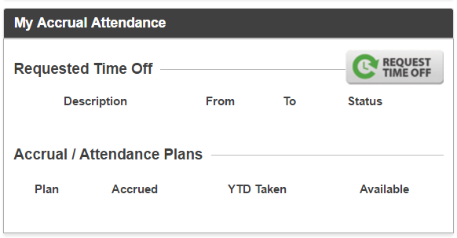

1. Pull down the **Requested Type** menu and select **AHRS – After Hours Staff.** Fill in the **Start Date** (date of the call out) and the **Comments** section with detailed information about the nature of the call. In the **Hours Per Day** field, place a “**1**” in the box and hit **Submit.** (If the call out falls on a Saturday, Sunday or Holiday, uncheck the box in the Days to exclude section.)

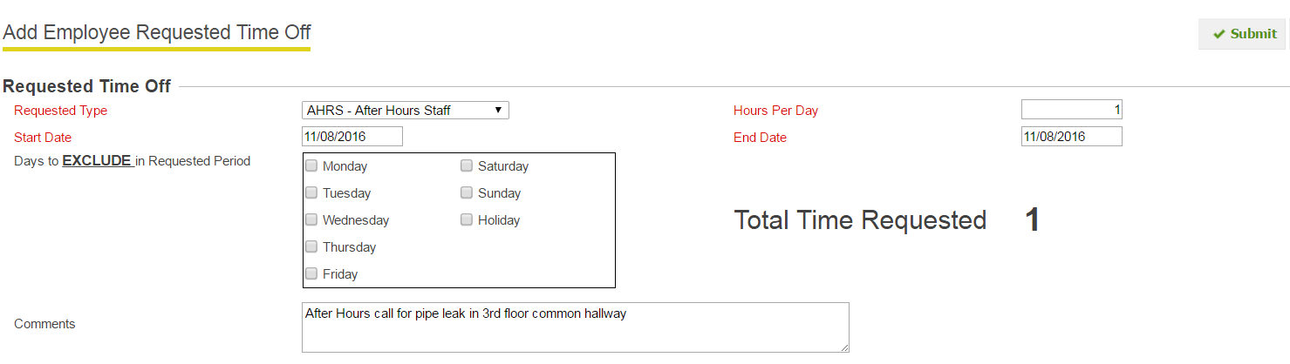

***The Manager should receive a notification from Netchex to approve this time and should ensure the call out was approved and accurate. Please be sure this process is followed during the time period in which it occurred.***

## Manager: Emergency After Hours Call

If a manager is called out after hours (would not apply if manager is already onsite from normal business hours including staying late), a flat fee of $75/hour will be paid to the manager for up to 2 hours. Any call outs that require a manager onsite for longer than 2 hours must be approved by the Director of Maintenance or the Director of Operations – Multifamily prior to the 2 hour limit reached.

The following steps should be taken to document the call out.

1. To process the flat fee through Netchex. Log in to your Netchex account as an employee and on your dashboard click on the Request Time Off Icon.



1. Pull down the **Requested Type** menu and select **AHM – After Hours Management.** Fill in the **Start Date** (date of the call out) and the **Comments** section with detailed information about the nature of the call. In the **Hours Per Day** field, place a “**1**” in the box and hit **Submit.** (If the call out falls on a Saturday, Sunday or Holiday, uncheck the box in the Days to exclude section.)

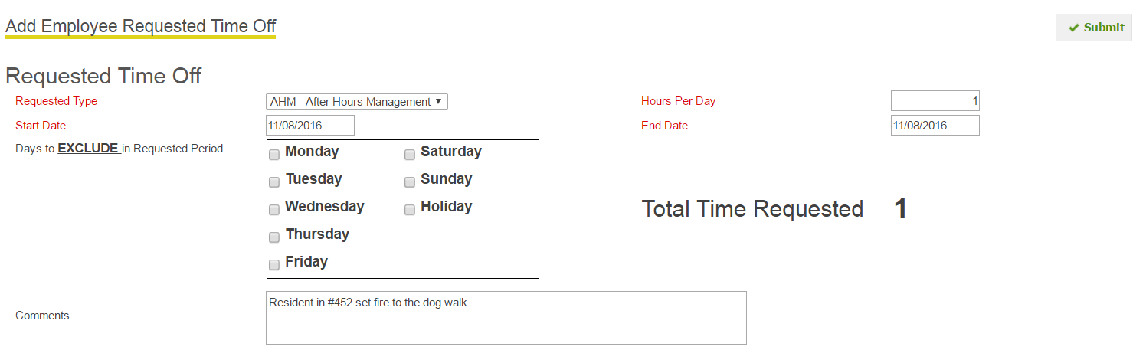

# Aged Receivables/ Work Order Reports

The following reports are due to the Director of Operations – Multifamily no later than the 15th of each month

## Current Resident Aged Receivables

The report should be sent with explanations on your efforts to collect outstanding balances. (Notice sent is not an acceptable explanation, please give details as to when notices were sent and how. Example: Balance due to underpayment of condo dues - statement sent on 9/12/2016, left message on 9/13/16.)

## Past Resident Aged Receivables

The report should be sent with explanations on your efforts to collect or refund if applicable. Past AR should always be $0.

## Work Order Report

(Reflecting Prior Month) - To run work order directory for previous month: Analytics > Work Order Analytics (aka WO Analytics)

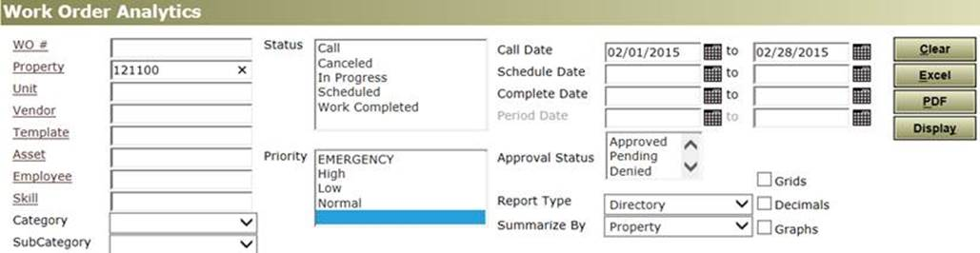

# Collections

* **Formal Lien/Collection Procedure**

A memo should be added under the resident’s profile in Yardi if a lien is filed or a resident is sent to collections. The following procedure should be implemented in conjunction with direction from the Board or Owners. All legal expenses incurred during the lien or collection process will be the responsibility of the delinquent resident.

* **Apartments Collections**

If rent has not been collected in full by the 5th of the month, a statement should be sent and a call must be made to the resident. Acceptable statement deliveries can include the following, sent through Yardi via correspondences and attached to the residents account, a statement emailed directly with a hard copy placed in their physical file, hand delivered (must include date, time and person who delivered at the bottom) and a hard copy placed in their physical file. If resident fails to respond by the 10th, a 5 day notice should be posted on the door of the resident (See **Sample B**). After 5 business days have passed with no response, eviction should be filed. After the eviction process and assuming tenant has moved out, a letter to the resident must be sent out within 20 days of gaining possession of the unit (See **Sample C**). The letter must show that the security deposit was forfeited and applied to any outstanding balance along with a detail of the charges (move out ledger). **This letter MUST be sent certified mail with return receipt.**

**IF A BALANCE IS DUE:** After the stated amount of time has passed (per your certified letter), and after several attempt by the manager to contact the individual, a full detail of the account should be sent to the Owner requesting permission to write off the charges and turn over to collections. If agreed upon, the file must be turned over to collections (Hunter & Warfield) and an email sent to the Director of Operations and your account manager requesting to write off the balance.

**Managers are advised to check with their Board of Director before following the procedure below!**

* **Condominium Collections**

If condo dues have not been collected in full by the 10th of the month, (reference your condo docs for accurate due date) a statement should be sent and a call must be made to the resident. Acceptable statement deliveries can include the following, sent through Yardi via correspondences and attached to the residents account, a statement emailed directly with a hard copy placed in their physical file, hand delivered (must include date, time and person who delivered at the bottom) and a hard copy placed in their physical file. If resident fails to respond or pay after the approved period of time set by the Board of Directors (usually 60 days), the BOD may elect to place a lien (handled by an attorney) on the property or place the owner into collections. Please note that a lien should be placed first unless otherwise directed by the BOD. A lien is only good for one year and will need to be renewed with any updated balances through the attorney that placed it originally. If the BOD would prefer the owner placed in collections, a 10 day demand letter should be sent to the resident (See **Sample D**). **This letter MUST be sent certified mail with return receipt.** After 10 business days have passed with no response and with written approval from the BOD, 40% of the total balance should be applied to the resident ledger and labeled as “Collection Agency Fees” through a chargeback to your accountant. Once the charge has been applied, a copy of the letter with the read receipt, resident’s ledger, most up to date contact info and tax record of resident (Orleans or Jefferson Parish Tax Assessors Office) shall be sent to Aldous & Associates. All condominium declarations and bylaws must be followed and supersede this policy or otherwise directed by the Board of Directors.

# Miscellaneous

## Bonus and Commissions Eligibility

Each individual property is responsible for establishing its own compensation structure with the input and direction of property ownership. For specific program details please refer to the on-site manager or supervisor. All commissions and/or bonuses will be paid through our payroll system and are subject to tax withholding as directed by state and federal law.

### Eligibility of Bonuses

Employees who provide a heightened level of service in carrying out their duties and contributing to the success of their assigned property may be eligible to participate in the bonus program as directed by property ownership. Participation, as determined at the discretion of ownership with input of the management team, will be proportion to effort and contribution to the project. Specific criteria include:

* Must be employed with Property One when bonus is distributed/paid out.
* Supervisor has approved the bonus and confirmed all requirements have been met.
* Employee has no corrective action notice in the last 3 months (during the period in which the bonus was accrued).

Eligibility of Commissions

Sales employees who have met the agreed upon conditions for commissionable event as laid out in the property commissions policy. Specific criteria include:

* If an employee is terminated for cause, all commissions will be forfeit.
* If employee gives notice to employer to terminate employment, the following must be followed to receive commissions:
* At least two weeks’ notice is given before last day of employment and full notice is worked to completion.
* Employee turns in commission worksheet to supervisor 5 days prior to last day of employment.
* All requirements for receiving commission is achieved.

## Slack Guidelines and Etiquette

* Use of Slack is internal only (Property One employees).
* It is fine to turn off Slack if you want to focus on your work. Again, this is a platform for us all to come together and share on topics that are relevant in our industry. I have created a few channels to get us all started. Feel free to add to the channels your personal experiences and solutions on how you overcame the problem. Remember this is a tool for us all to learn and grow.
* Important discussions should happen over our normal email platform (propertyone.com) so that they don’t get lost. If an important discussion happens in Slack you should recap it with an email.
* Please do not use profanity or be inappropriate in anyway. This should be treated similarly to how we behave on our email. Think of it this way, if you wouldn’t say it to Paul D, then don’t type it out in Slack.
* There are several ways to communicate either as a group via “channels” or by direct message. Direct messages allow for one on one conversations and/or group messages but are always private in regards who has been invited. Guidelines still apply to direct messages.
* You can update your status or use Do Not Disturb mode to indicate to the team that you are unavailable. Don’t expect immediate responses from your team members, especially if they are in DND mode.
* You can add a profile picture which is highly encouraged.
* You can use Slack as a web-based platform or download the app to work on your phone or desktop.

# Hurricane/Weather Systems

* **DEFINITIONS**
  + Essential Personnel - Building Staff including Property Managers, Maintenance and Engineering Personnel.
  + Nonessential Personnel – Corporate staff such as administration, accounting, leasing and sales.
  + Company Management - Company Executive Committee
  + Voluntary Evacuation - Parish Officials suggest/ask all residents to evacuate the area.
  + Mandatory Evacuation – Parish Officials require all residents to evacuate the area.
* **DEPRESSIONS, TROPICAL STORMS, HURRICANES** 
  + Company Management **will** **monitor** potential developments of all weather systems particularly tropical depressions, tropical storms, and hurricanes. (Hurricane season is from June 1st to November 30th )
  + All Company personnel should always monitor approaching systems as well. Emergency alert systems will need to be added to phones.
  + Company Management and the Property Management Division **will meet** if a storm system is approaching or develops in the Gulf of Mexico.
  + **Preliminary preparations will begin** if a storm path is believed to be in the direction between Florida and Texas. Emergency supplies (See Property Hurricane Procedures attached) are to be inventoried by Building Staff to determine all appropriate supplies are in place and on hand.
* Once a tropical depression, tropical storm, or hurricane develops in or enters the Gulf of Mexico, all Property One Maintenance/Engineering Staff will begin evaluating and  securing all rooftops, remove accumulated debris, etc. Management will closely monitor the weather system. Once the area of impact is determined, staff in conjunction with management will prepare the building for the storm system. Check with emergency restoration and security vendors and determine their availability.

The following procedures include but are not limited to the following:

* Roof – secure all doors, hoods, cooling towers, etc.
* Roof – remove any loose debris
* Roof – check tenant satellites/antennas
* Interior‐ check emergency, stairwell and exit lighting‐ check batteries
* Interior‐ check windows
* Exterior‐ check and remove any debris from roof drains.
* Exterior – check for any debris & remove and/or secure accordingly
* Exterior – check the garage; both upper and lower levels.
* Exterior – bring in all ash trays / trash cans / pool equipment/ other moveable objects
* Exterior – remove flags
* Exterior – check signage to insure it is secure
* Exterior – secure all doors and lock down when appropriate
* Exterior – secure tops of dumpsters and empty
* Exterior – check and secure all panels on the chillers
* Exterior – place slip and fall cones in common areas near entrances and exits
* Generators – test, check fuel, battery

Upon the issuance of a voluntary or mandatory evacuation, the following needs to be

Performed.

* Check all suites and vacant areas to insure that blinds and doors to perimeter areas are

closed.  Remove any objects from windowsills.

* Check all major building equipment. Ensure the emergency fire pump is operational

including

* fire alarm system.
* Verify that all emergency backup batteries are operational.
* Move all elevators to top floor and lock down if requested by board/owners.
* Turn all air handler units off (commercial properties only).
* Turn all lights out (commercial properties only).
* Turn off chillers (commercial properties only).
* Optional…board up front entrance doors.

In storage, on site, the following supplies should be maintained at a minimum:

* Plywood (at least 10 sheets) and double headed nails
* Plastic sheeting – visqueen
* Tarps – roof
* Tape – duct and masking
* Rope – bungee cords
* Tools – hammer, drill, etc.
* Batteries (insure batteries are charged)
* Flashlights (3)
* Battery operated radio
* Drinking water
* Non‐perishable food
* First Aid Kit
* Extension cords
* PIGS and absorption pads
* Orange cones
* Lighting (glow sticks, etc)

Optional:

* Generator (portable)
* **72 HOURS PRIOR TO LAND FALL**
  + Company Management will meet to determine if and when Property One will go into **EMERGENCY MODE**. *(Emergency Mode describes the specific actions taken by Company Management and Building Staff to secure Property One offices as well as all managed properties that may be impacted. This mode could also occur during a flood, fire or civil disturbance)*
  + Once **EMERGENCY MODE** is in effect, Building Staff will begin preparing all impacted properties within their responsibility (See Hurricane Property Procedures attached.) All employees will be notified to be on alert.
  + Property Management is to notify all Tenants/Residents in affected properties that the property has gone into **EMERGENCY MODE** and to listen for further information / instructions.
  + Tenants are to be advised to prepare their suites as described in the Hurricane Property Procedures. Tenants are to be asked to check their spaces for any potential problems and advise Property Management accordingly.
  + Email the resident contact information to yourself and to all board members, in addition to printing a hard copy to have on hand.
  + **48 HOURS PRIOR TO LANDFALL**
  + Building Staff will physically check all building areas including roofs, windows, doors, fences, hatches, and verify building emergency inventory.
* Building Staff will double-check all Tenant/Resident areas to insure all perimeter doors and blinds are closed.
* **24 HOURS PRIOR TO LAND FALL**

*Assuming a Voluntary or Mandatory Evacuation*

* Property Management will place key employees (Essential Personnel) on mandatory emergency call back notification and advise all other non-essential staff of the same. During the impending emergency, mandatory emergency call back Staff will receive Emergency Pay while on duty. Emergency Payis defined as double pay. Employees must “report” to work to be eligible for emergency pay.
* **Voluntary Evacuation**

Under a voluntary evacuation by Parish officials and following an announcement by Company Management all Essential Personnel will be required to report to work and complete their individual property storm preparation (See Hurricane Property Procedures attached) and report completion to their supervisor. All Nonessential Personnel will be dismissed at this time unless notified otherwise. All Nonessential Personnel are to notify their supervisor of location and contact information for post storm check in.

* **Mandatory Evacuation**

Under a mandatory evacuation by Parish officials all Company Personnel are dismissed. Following the storm all personnel are required to check in with their supervisors. All Essential Personnel are to notify their supervisor of location and contact information for post storm check in.

* **POST STORM RESPONSIBILITIES**
* Essential personnel will be provided with reentry credentials (re-entry placards).
* Company Management will monitor all news casts and radio communications for reentry directive from parish officials.
* All company personnel are to report in as soon as possible to their supervisors. The Property One website will provide information (bottom of home page) on building and office status.
* Once the area is safe to return Building Staff must perform a site survey of each property for storm damage as soon as possible and report in to their supervisor.
* Be observant of dangerous conditions at each property. Report any property damage to Company Management.
* Evaluate and perform (if possible) emergency and/or temporary repairs until contractors can be notified.
* **Phone Apps and Contacts**
* Entergy
* Hurricane Tracker
* The Weather Channel
* Emergency by American Red Cross
* Radar Now! Weather Radar
* Hurricane by American Red Cross