Under Contract Memorandum

Property:
Purchase Price:
Effective Date:
Deposit:
Due Diligence Period:
Closing Date:
Commission:
Purchaser’s Contact Information:

- 6/10 – 9/4 Study Period (90 day) begin with delivery of materials (6/10/16)
- 6/23/16 Effective Date (when Purchase Agreement is delivered to title company)
- 6/28/16 Consent forms by Seller’s investors (5 days), no notice required
- 7/3/16 Delivery of materials by seller (10 days after Effective Date) to Purchaser
- 9/4/16 Purchaser to eliminate lease obligations
Notes:
- Study Period – reference end of section (items (a) – (t) delivered by Seller to Purchaser on June 10, 2016, which began the Study Period, see below)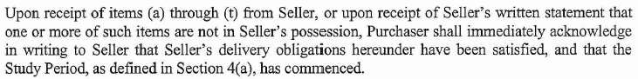
- Effective Date – reference section 31. pages 15 & 16 (only 2 executed purchase contracts were delivered by Purchaser to Seller, they were executed by Seller and delivered to title company on June 23, 2016, which becomes the effective date of this contract as stated below)
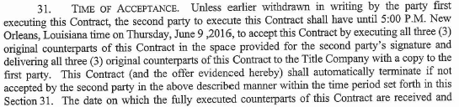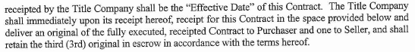
- Consent forms by Seller’s investors – reference Addendum to 4A (all consents to this contract were executed and in Seller’s possession prior to the Effective Date, copies were delivered to the Purchaser)
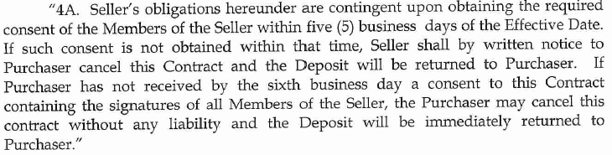
- Delivery of materials by seller (10 days after Effective Date) – reference section 9 (All materials were delivered to Purchaser prior to June 10, 2016.
- Purchaser to eliminate lease obligations at – reference last sentence of 4d.

